
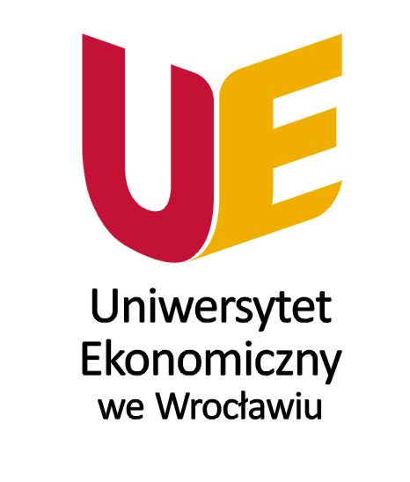

ORGANIZER
Wrocław Univerity of Economics
The Faculty of Economy, Management and Tourism in Jelenia Góra
Ph.D. Piotr Gryszel; Ph.D. Sabina Zaremba-Warnke
and

Co - organizer:
Academic Coordination Centre
in the Euroregion Neisse - Nisa - Nysa (ACC)

Contact:
Uniwersytet Ekonomiczny we Wrocławiu
Wydział Ekonomii, Zarządzania i Turystyki w Jeleniej Górze
58- 500 Jelenia Góra, ul. Nowowiejska 3
tel. +48 75 75 38 252, fax. +48 75 75 38 230
sabina.zaremba-warnke@ue.wroc.pl

Conference venue:
Guestehouse: Królowa Karkonoszy in Szklarska Poręba
Słowackiego 11a Street; Szklarska Poręba
POLAND



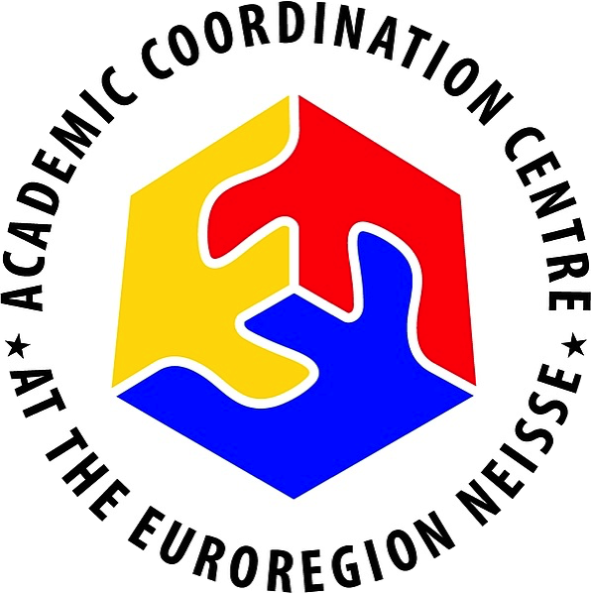








12th International Conference
of Young Scientists
of Lower Silesian Voivodship
and
of the Academic Coordination Centre in Euroregion Neisse-Nisa-Nysa

10-11th May 2018
Project co-financed by
Marshal Office of the Lower Silesian Voivodship
Projekt dofinansowany przez
Urząd Marszałkowski Województwa Dolnośląskiego
The conference is the result of cross – border cooperation of state universities Academic Coordination Centre
in the Euroregion Neisse - Nisa - Nysa.

We would like conference participants to present their research papers and research projects on both their individual goals of science (PhD) and the
activities of Scientific Circles.
Reported papers, after the positive reviews, will be published in the monograph.

We would like to invite:
- Students;
- Members of student organizations, Scientific Circles established in different universities;
- Graduate students preparing for doctoral theses and supervisors.

Conference fee:
- 1-day participation: 10.05.2018 – 100 PLN (from 9.00 to 17.30)
- 2-days participation: 10-11.05.2018 - 250 PLN.
The fee includes conference materials, publication, participation in meeting, board, accommodation, study-tour.
Bank account number:
BZ WBK, Jelenia Góra
IBAN: PL 10 1090 1926 0000 0001 1388 8430
SWIFT: WBKPPLPP
With a note: Young Scientist ACC 2018 with the name of the participant.

Conference program - 10.05.2018  - ⁰⁰ participants arrival, registration  - 10⁰⁰ conference opening  - 10¹⁵ proceedings  - 13³⁰ lunch  - 14³⁰ proceedings  - 17³⁰ closing remarks  - 19³⁰ dinner and integration evening | Conference program - 11.05.2018  - 7³⁰ breakfast  - 9⁰⁰ study-tour innovativeness of Lower Silesian enterprises, the idea of smart specialization and clusters.  - 13³⁰ lunch  - 17³⁰ closing study-tour
Calendar:
To participate in the conference schedule one should strictly pay attention to:
- deadline for submitting applications: 26.04.2018, e-mail: sabina.zaremba@ue.wroc.pl
- payment terms: 100 or 250 PLN: 30.04.2018,
- deadline for sending the paper: 15.05.2018.

Application: http://www.ezit.ue.wroc.pl/youngscientists

Editorial requirements for authors.
The manuscript should be in MS Word format (.doc or .docx), submitted as an email attachment to our email address piotr.gryszel@ue.wroc.pl with a note: Young Scientist ACC 2018 (dead line: 15.05.2018).
Articles should be written in English or in Polish, in a clear, succinct and accessible manner.
1. COMPOSITION
1. Fonts:
a. Title: Times New Roman 14 points, bold
b. Subtitles: Times New Roman 12 points, bold
c. Body of the paper: Times New Roman 12 points
d. Table: Times New Roman 10 points
2. On a separate front page: the name of the Author / Contributor by and Affiliation: Times New Roman 11 points
3. Margins: 2.5 cm
4. Space: 1,5
5. Author’s / co-author’s name, Title – centred
6. Titles and subtitles: left-aligned
7. Body of the paper: justified
8. Spacing:
a. Title, sections, subsections: 12 points
b. Body of the paper: 6 points
c. Table: 0 points
9. Indent: body of the paper – special protrusion “first line” 1,25 cm
10. Notes: parenthesis – ex. (Berry 2003: 12)
11. Tables: black and white, with no shading, placed vertically, published in the text, number, and title of the above explanations and the source below, when moving to the next page - number, title and table header are repeated
2. STRUCTURE
1. Name and surname of the author and co-author (if any)
2. Affiliation
3. E-mail address, telephone number
4. Brief information about the author in English (up to max. 5 lines)
/on a separate first page/
5. Title
6. Abstract (up to 6 lines)
7. Key words (up to 5, in alphabetical order)
8. Introduction
9. Sections and subsections (numbering according to the following example):
a. The first subtitle
b. The second subtitle etc.
10. Summary (conclusions, findings and limitations)
11. Number of pages: 8 - 10 pages
3. REFERENCES
Camuffo, F.A. (2005), Benefits of inter-firm cooperation, in: Norman, M. (Ed.), Creating the value through partnerships, Elsevier, New York, NY, pp. 15-20.
The condition for forwarding the text to reviewing process is an absolute compliance with the editorial requirements and high-quality of English language.

